
NORTHERN EDUCATION DIVISION
2023 MSCE MOCK EXAMINATION
BIOLOGY
PAPER II
PROVISIONAL MARKING SCHEME
______________________________________________
- Collect green leaves and crush or grind the leaves using pestle and mortar¹. Place the crushed or ground leaves into a glass beaker¹. Add alcohol to half fill the beaker¹. Place the beaker into a large glass beaker half filled with water¹. Heat the larger beaker until the alcohol in the small beaker turns green¹. Remove the alcohol mixture from the beaker and filter it into another beaker¹. Cut a strip of filter paper and suspend it into the container containing the coloured alcohol¹. Allow the filter paper to absorb the coloured alcohol for some time and observe the colours on the filter paper¹. The filter paper will show the green, orange and yellow colours¹. This means that leaves have chlorophyl, carotene and xanthophyll pigments¹. (10 marks)

- Soak some bean seeds for two days to allow them to germinate¹. Take a second set of the bean seeds and boil to kill them¹. Wash both sets of beans with a diluted disinfectant¹. Put each group of beans into sterilized vacuum flasks while not filling to the brim¹. Put a thermometer into each flask and hold it in place with cotton wool at the mouth of the flask¹. Note the temperature of the flask and record¹. Support each flask upside down using a clamp stand and leave them for five days¹. Note the new temperature in each flask after five days¹. There will be a temperature rise in the flask containing germinating seeds¹. This means that germinating seeds break down stored carbohydrates in the process of respiration to release energy which is in form of heat¹.
(10 marks)
Continued/…
- a. Ranging from 70 mm to 120 mm ¹ (1 mark)

b.
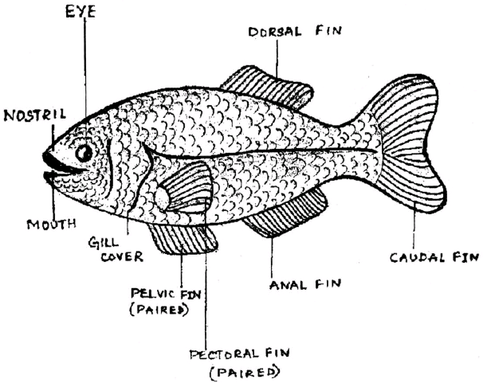
1 mark for correct drawing
1 mark each for two correct labels (3 marks)
c. Correct formula ¹
Correct substitution ¹
Correct answer which should include X symbol ¹ (3 marks)

d. Has streamlined body¹ to reduce drag/water resistance¹
Scales overlap facing backwards¹ to move through water easily¹
Has fins¹ to control movements¹
(2 marks)
Continued/…
- a.
Length(mm) | 10 | 11 | 12 | 13 | 14
Number of groundnuts | 2 | 3 | 5 | 4 | 1
1 mark for correct 3 (2 marks)
b.
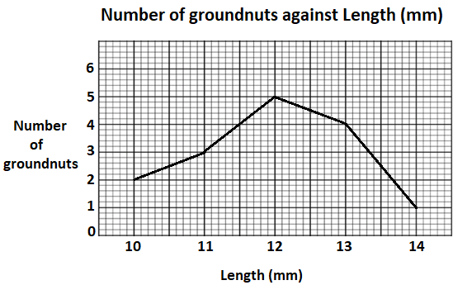
1 mark for correct labelling of axes
1 mark for proper scaling
1 mark for correct location of points
1 mark for connecting the points
(4 marks)
c. Continuous variation ¹ (1 mark)
d. $Mean=\frac{Sum of lengths}{Total number of groundnuts}$ 1
$=\frac{2×10+3×11+5×12+4×13+1×14}{2+3+5+4+1}$ 1
$=\frac{20+33+60+52+14}{15}$
$=\frac{179}{15}$
$=11.9mm$ 1 (3 marks)

END OF PROVISIONAL MARKING SCHEME

